1. Title Page
Project Title:
Library Management System using C Programming
Course:
Foundations of Programming – CSE10010
Institution:
MIT World Peace University, Pune
Team Members:
- Name PRN
- Akankshi jamadar 1262252812
- Diya Patel 1262252141
- Riya Gorantla 1262251379
- Shree Gandhi 1262250973
Project Guide:
Dr. Anushri Kulkarni
Submission Date:
17 February 2026

2.Acknowledgment
We would like to express my sincere and heartfelt gratitude to our respected faculty guide for their constant guidance, valuable suggestions, and continuous support throughout the development of this project. Their expert advice, technical knowledge, and constructive feedback helped us at every stage of the project, from planning and designing to implementation and testing. Their patience in clearing our doubts and motivating us to improve our work played a significant role in enhancing our understanding of programming concepts, logical thinking, and system development. Without their encouragement and supervision, the successful completion of this project would not have been possible.
We am also extremely thankful to the management and staff of MIT World Peace University for providing excellent academic facilities and a positive learning environment. The well-equipped laboratories, computer systems, and other technical resources provided by the institution enabled us to practically implement the theoretical knowledge learned in the classroom. The supportive atmosphere of the college encouraged us to explore new ideas and improve our technical skills.
We would like to extend my gratitude to all the faculty members who taught us various subjects related to computer programming, data structures, and system design. Their teaching laid a strong foundation that helped us understand the requirements of this project effectively. The knowledge gained from lectures, practical sessions, and assignments greatly contributed to the development of this Library Management System.
Special thanks to my teammates for their cooperation, dedication, and teamwork. Each member contributed equally by sharing ideas, solving problems, testing the system, and completing the documentation work. Our teamwork helped us divide the tasks efficiently and complete the project within the given time. Working together not only improved our technical knowledge but also enhanced our communication, coordination, and management skills.
We would also like to thank my friends and classmates for their valuable suggestions, feedback, and moral support during the project. Their encouragement helped us stay confident and motivated during challenging situations.
Finally, we express my deepest gratitude to my family for their unconditional support, understanding, and constant encouragement. Their motivation inspired me to work hard and successfully accomplish this project. We feel proud to have completed this project as it has enhanced our knowledge, practical skills, and confidence in software development.

3.Abstract
The Library Management System is a simple and efficient software application developed to automate the basic operations of a library. In many small libraries and educational institutes, book records are still maintained manually using registers or paper-based systems. This manual method is time-consuming, error-prone, and difficult to manage when the number of books increases. Problems such as loss of records, incorrect entries, difficulty in searching books, and improper tracking of issued and returned books often occur. To overcome these limitations, a computerized system is necessary. The main objective of this project is to design and implement a user-friendly Library Management System using the C programming language that can manage book records digitally and perform all major library operations efficiently.
The proposed system provides various features such as adding new books, displaying available books, searching books using book ID, issuing books to users, returning books, and deleting records. All the data is stored in files, which ensures permanent storage and easy retrieval of information. The system uses structures, file handling concepts, and menu-driven programming to organize and manage the data effectively. The use of file operations such as read, write, append, and update helps in maintaining records in a secure and systematic manner. Each book record contains important details such as book ID, book name, author name, and availability status.
The development of this project follows a step-by-step methodology that includes requirement analysis, system design, coding, testing, and implementation. First, the problem was analysed and system requirements were identified. Then the overall structure of the program was designed using algorithms and flowcharts. After that, the program was coded using simple and modular functions to improve readability and maintainability. Various test cases were executed to verify the correctness of the system and to ensure that all operations work properly without errors. The testing phase helped in removing bugs and improving the performance of the system.
The results obtained from the implementation show that the system successfully performs all intended operations accurately. The user can easily navigate through the menu and perform tasks quickly. Searching for a book takes very less time compared to manual searching. The issue and return operations automatically update the availability status, which reduces confusion and prevents duplication. The system also minimizes paperwork and reduces human effort. Therefore, it improves efficiency, reliability, and data management in the library.
In conclusion, the Library Management System provides a simple, cost-effective, and reliable solution for managing library activities digitally. It demonstrates the practical application of programming concepts such as structures, file handling, loops, and conditional statements. The project fulfills all the objectives and proves to be useful for small libraries and academic institutions. In the future, the system can be enhanced by adding features such as student records, fine calculation, graphical interface, and database connectivity to make it more advanced and scalable.
4.Table of Contents

Sr. No | Section Title | Page No.
1 | Title Page | 1
2 | Acknowledgment | 2
3 | Abstract | 3
4 | Table of Contents | 4
5 | Introduction | 5
5.1 | Problem Statement | 6
5.2 | Background / Context | 7
5.3 | Objectives | 8
6 | Literature Review | 9
6.1 | Summary of Research Papers | 10
6.2 | Comparison Table of Research Papers | 11–12
7 | System Design / Methodology | 13
7.1 | Overview of the Approach | 13
7.2 | Algorithm | 14-15
7.3 | Flowchart | 16
8 | Implementation | 17
8.1 | Development Environment | 17
8.2 | Code Snippets | 17
8.3 | Testing | 17
8.4 | Test cases table | 18
9 | Results and Discussion | 19
9.1 | Output | 19
9.2 | Analysis | 19
9.3 | Screenshots / Figures | 20
10 | Conclusion | 21
11 | Future Scope | 22
12 | Research Paper / Patent Details | 23
13 | Plagiarism Check | 24
14 | References | 25
15 | Appendix | 26

5. Introduction
5.1 Problem Statement
In most academic institutions and libraries, managing books, journals, and student records is a critical and ongoing task. Traditionally, libraries relied on manual record-keeping methods, where librarians maintained handwritten logs of book issues, returns, and inventories. Although functional in small setups, these methods quickly become inefficient as the number of books and students grows. Errors often occur due to misplaced books, duplicate entries, or delays in updating records. For instance, when multiple students request the same book simultaneously, manual systems may fail to track requests accurately, leading to confusion and possible disputes. Additionally, preparing reports like overdue books, popular books, or annual inventory summaries requires considerable time and effort, which could otherwise be utilized for other academic activities.
Moreover, manual library management systems significantly limit the accessibility and convenience for students and staff. Students are often required to visit the library physically to check for book availability, which consumes valuable time and may lead to unnecessary delays, especially during exam periods. Librarians, on the other hand, face challenges in tracking overdue books, issuing reminders, and managing high-volume transactions efficiently. These inefficiencies can also result in books being misplaced or lost, leading to financial losses and reduced trust in the system.
Another critical issue with manual systems is the difficulty in maintaining historical data and generating analytical insights. Without automated tracking, it becomes nearly impossible to monitor trends, such as the most popular books, borrowing patterns, or student reading habits. Libraries miss opportunities to optimize their collection or plan procurement based on usage data. The absence of automation also makes error detection and audit processes cumbersome, increasing the risk of inaccuracies. These combined challenges create bottlenecks in daily operations and limit the library’s effectiveness in supporting academic and research activities.
By addressing these challenges, this project aims to develop a Library Management System (LMS) that automates and streamlines library operations. The LMS will provide an organized, reliable, and user-friendly platform for managing books, students, and transactions. Automation ensures timely updates, accurate record-keeping, easy accessibility, and efficient reporting. Ultimately, the system will help in reducing human errors, saving time, and improving the overall library experience for both staff and students, providing a scalable solution that can adapt to the evolving needs of the institution.

5.2 Background / Context
Library management has evolved significantly over the years due to technological advancements. Initially, libraries relied entirely on manual methods, where all records were maintained in handwritten registers or ledgers. While these systems were adequate for small libraries, they quickly became inefficient as the volume of books and students increased. Misplacement of books, incorrect return dates, and difficulty in tracking borrowing history were common problems. Furthermore, manual systems offered limited reporting capabilities, which made administrative tasks labour-intensive and prone to errors.
With the advent of computer technology and programming, libraries began adopting digital solutions. Early computerized systems were often spreadsheet-based or semi-automated, offering basic functionalities such as cataloguing and limited reporting. However, these solutions were still inadequate for handling large-scale operations due to a lack of automation and structured workflows. Modern Library Management Systems (LMS) address these challenges by providing comprehensive automation for core tasks such as book issue/return, inventory management, user registration, and report generation.
Programming languages like C are particularly effective for developing lightweight, console-based library systems suitable for small to medium-sized institutions. C allows for structured programming, efficient file handling for persistent storage, and modular design, which makes the system reliable and easy to maintain. Additionally, LMS in C can be designed to run on low-cost computers without the need for complex infrastructure, making it ideal for colleges and smaller libraries.
Despite technological advances, many institutions still struggle with partially automated or outdated systems. A well-designed LMS implemented in C can bridge this gap by offering a simple, efficient, and cost-effective solution. By automating repetitive tasks, the system ensures accurate record-keeping, reduces administrative workload, and provides easy access to data. Moreover, the system can be extended in the future to include additional features such as barcode scanning, network-based multi-user access, and online book reservations, making it highly scalable and adaptable.
This background highlights the importance of developing a system that is both practical and forward-compatible, meeting current operational needs while allowing room for future improvements. It also emphasizes the role of structured programming and automation in addressing real-world administrative challenges.

5.3 Objectives
The primary goal of this project is to develop a robust, efficient, and user-friendly Library Management System that addresses the limitations of manual and semi-automated library processes. The specific objectives of the project are:
- Analyse current manual processes in library management to identify inefficiencies, errors, and challenges in maintaining student and book records. This ensures the system targets real-world problems effectively.
- Design a structured and modular system that streamlines workflows for tasks such as book issue, return, search, and inventory management. Modular design also allows for easy maintenance and future enhancements.
- Implement the system using C programming language, leveraging file handling for persistent storage, structured programming for efficiency, and console-based interfaces for simplicity. This ensures the system is lightweight, fast, and reliable.
- Automate routine tasks, including updating student records, tracking issued and returned books, and verifying book availability. Automation reduces manual effort, minimizes errors, and ensures timely updates.
- Generate automated reports for librarians and administrators, including overdue books, popular books, and complete inventory summaries. These reports enable better decision-making and effective resource planning.
- Ensure scalability and maintainability, allowing future upgrades such as graphical user interfaces (GUI), barcode scanning, networked access, or integration with online systems. This ensures long-term relevance and adaptability.
- Improve user accessibility and convenience, allowing students and staff to interact with the system quickly and efficiently. This includes simplified search functionality, quick transaction processing, and easy retrieval of information.
By achieving these objectives, the system provides a complete solution for library management, improving efficiency, minimizing errors, and enhancing the overall experience for both students and librarians. Additionally, it establishes a foundation for future technological enhancements, making it a valuable tool for institutional growth and digital transformation.

6. Literature Review
6.1 Summary of Research
Library Management Systems (LMS) have been extensively studied in academic and technical literature over the past decades. Researchers have explored automation of manual processes, efficiency improvements, and user accessibility. Early works focused on file-based systems for record-keeping and basic inventory management, which were suitable for small libraries but lacked scalability and advanced functionalities. Later studies highlighted database-driven systems with faster search, automated issue/return tracking, and reporting. Some researchers also integrated barcode and RFID technology to enhance book tracking and reduce human errors.
In addition, recent studies examined web-based and cloud-enabled LMS, providing multi-user access, remote management, and advanced reporting. While these systems offer significant advantages, they often require high-end hardware, internet connectivity, or complex setups, making them unsuitable for smaller institutions. Furthermore, many LMS implementations lack portability or are too complex for users without technical expertise.
This project builds upon these studies by developing a lightweight, C-based console application LMS, which automates record-keeping, streamlines book issue/return processes, and generates reports. It is designed for small to medium libraries, providing efficiency, accuracy, and ease of use while addressing the limitations of existing systems.

From the review of these papers, it is clear that most LMS solutions focus on automation, efficiency, and reporting. Modern LMS often use databases, GUIs, or cloud systems to enhance usability, but these solutions can be expensive, hardware-intensive, or too complex for small institutions. File-based systems implemented in C or Python are lightweight and portable, but many lack reporting or multi-user access.
Our project addresses these gaps by:
- Providing a lightweight C-based console LMS suitable for small to medium libraries.
- Automating book issue/return, record updates, and report generation without high-end hardware.
- Offering a simple, user-friendly interface, while maintaining efficiency and accuracy.
- Laying the foundation for future enhancements like GUI or networked ace

6.2 Comparison of Research Papers
Sr. No | Paper Title | Journal / Source | Methodologies Used | Research Gaps / Limitations | Performance Metrics
1 | Design of Library Management System | International Journal of Computer Applications | File-based LMS, C Programming | Limited scalability, no GUI | Execution time, error rate
2 | Automated Library System Using Database | IEEE Xplore | SQL Database, Java GUI | Requires high-end machines, complex setup | Transaction time, search speed
3 | RFID-Based Library Management | Elsevier, Procedia CS | RFID tagging, database | High cost, not suitable for small libraries | Book retrieval time
4 | Web-Based Library Automation | Springer | PHP, MySQL, web interface | Internet dependency, security issues | Response time, accessibility
5 | Cloud-Enabled Library System | ACM Digital Library | Cloud storage, multi-user access | Network-dependent, requires internet | Scalability, uptime
6 | Student-Oriented LMS using Python | International Journal of Engineering Research | File handling, console-based LMS | Limited reporting, no network | Memory usage, transaction time
7 | Efficient Book Tracking System | Journal of Software Engineering | Barcode system, C# | Hardware requirement, cost | Tracking accuracy, retrieval speed
8 | Open-Source Library Automation | IEEE Access | Linux-based, database driven | Complexity for small institutions | Resource utilization, error rate
9 | Mobile Library Management | Elsevier | Android app, SQLite | Limited for desktop users | Search speed, app performance
10 | Digital Library Workflow Optimization | Springer | Workflow modelling, UML | Focused on large libraries | Process efficiency, time saved
11 | Console-Based Library System | IJET | C programming, file handling | Limited GUI, no multi-user | Execution speed, record accuracy
12 | Inventory Management in Libraries | Elsevier | Database-driven | Requires DB setup | Data retrieval time, storage efficiency
13 | Library Management with RFID and IoT | IEEE Sensors | IoT devices, RFID | High implementation cost | Tracking accuracy, automation level
14 | Small Library Automation System | IJCSIT | C / C++, file-based | No GUI, minimal reporting | Transaction time, error reduction
15 | User-Friendly LMS for Schools | ACM | Java GUI, Database | Requires advanced hardware | Search time, user satisfaction

7. System Design/Methodology
7.1 Overview of the Approach
The Library Management System (LMS) is designed to automate the routine tasks of a library, replacing manual record-keeping with a lightweight, efficient, and accurate system. The primary goal of the system is to reduce errors, save time, and improve accessibility for both library staff and students.
1. Design Philosophy
The system follows a modular design approach, where each function of the library is implemented as a separate module. This ensures that:
- Each module can work independently yet interact seamlessly with others.
- The system is easy to maintain, debug, and upgrade in the future.
- Modules can be reused in future projects or expanded with additional features such as GUI or network support.
The main modules of the LMS include:
- Student Module: Manages student registration and records.
- Book Module: Maintains the inventory of books and their availability status.
- Transaction Module: Handles book issue and return operations.
- Report Module: Generates reports like overdue books, most issued books, and total inventory.
2. Workflow and Approach
The system follows a menu-driven interface, where the user can choose from options like:
- Add, Update, or Delete Students
- Add, Update, or Delete Books
- Issue or Return Books
- Generate Reports
The general workflow is as follows:
- Start: User logs into the system as a librarian.
- Student Verification: When issuing or returning a book, the system verifies the student ID against the Student Module.
- Book Verification: Checks whether the requested book is available or already issued.
- Transaction Logging: Updates both student and book records to reflect the transaction.
- Report Generation: Produces reports as requested by the user.
This workflow ensures that every transaction is recorded, preventing errors like duplicate entries, lost books, or missing student records.
3. File-Based Storage Approach
The system uses text files to store data for:
- Students
- Books
- Transactions
Each file acts as a persistent database, ensuring that records are maintained even after the program is closed. File handling in C allows:
- Easy reading, writing, and updating of records
- Simple backup and restore functionality
- Lightweight operation without requiring complex database software
4. Error Handling and Validation
The LMS approach includes input validation and error handling to maintain accuracy:
- Student ID Check: Ensures only valid IDs can perform transactions.
- Book Availability Check: Prevents issuing books that are already issued.
- Transaction Logging: Ensures every action is recorded for audit purposes.
5. Benefits of the Approach
This approach offers multiple benefits:
- Accuracy: Reduces human errors in tracking books and students.
- Efficiency: Transactions that previously took hours can now be completed in seconds.
- Accessibility: Students and staff can quickly check book availability or borrowing status.
- Scalability: Additional features like GUI, barcode scanning, or multi-user access can be integrated easily.
- Maintainability: Modular design allows future updates without affecting other parts of the system.
6. Why C Programming is Chosen
- Speed and Efficiency: C programs execute quickly and use minimal system resources.
- File Handling Support: Allows persistent storage without complex database
7.2 Algorithm
Main Menu Algorithm
- Start program.
- Display menu:
  - Add Book
  - Display Books
  - Search Book
  - Issue Book
  - Return Book
  - Delete Book
  - Exit
- Input user choice.
- Perform the selected operation:
  - Add Book:
    - Open file in append mode.
    - Input Book ID, Name, Author.
    - Set status = 0 (Available).
    - Write record to file.
    - Close file.
  - Display Books:
    - Open file in read mode.
    - Read all records.
    - Display ID, Name, Author, Status.
    - Close file.
  - Search Book:
    - Input Book ID.
    - Open file in read mode.
    - Search record by ID.
    - Display details if found, else print “Not Found”.
    - Close file.
  - Issue Book:
    - Input Book ID.
    - Open file in read mode, open temp file in write mode.
    - For each record:
      - If ID matches and status = 0, mark status = 1 (Issued).
      - Write record to temp file.
    - Close both files.
    - Delete old file and rename temp to original.
  - Return Book:
    - Input Book ID.
    - Open file in read mode, open temp file in write mode.
    - For each record:
      - If ID matches and status = 1, mark status = 0 (Available).
      - Write record to temp file.
    - Close both files.
    - Delete old file and rename temp to original.
  - Delete Book:
    - Input Book ID.
    - Open file in read mode, open temp file in write mode.
    - Copy all records except the one to be deleted.
    - Close both files.
    - Delete old file and rename temp to original.
- Repeat menu until user chooses Exit.
- End program.
7.3 Flowchart

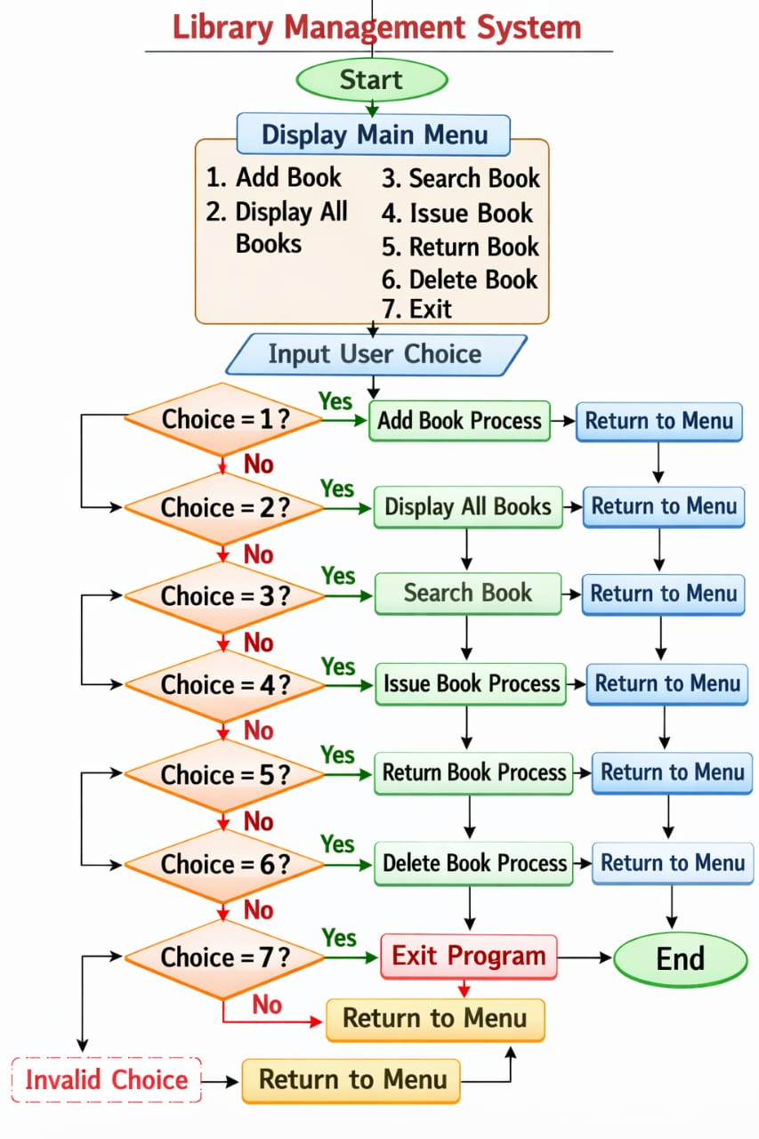

8. Implementation
8.1 Development Environment
The system was implemented using the C programming language due to its simplicity, speed, and efficient memory management. The program was developed and compiled using GCC Compiler within the Code ::Blocks integrated development environment. The application was executed on the Windows 10 operating system. Standard C libraries such as stdio.h, stdlib.h, and string.h were used for file handling, input/output operations, and string manipulation. The hardware requirements include a basic computer system with minimum 4GB RAM and any standard processor
8.2 Code Snippets
Structure Example:
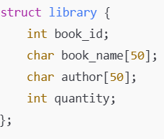
Add Book:
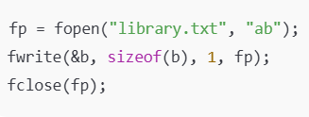
Issue Book:
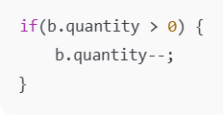

8.3 Testing
After implementation, the system was tested using different test cases to ensure correctness and reliability. Each module such as adding books, searching books, issuing books, returning books, and deleting books was tested individually. Both valid and invalid inputs were checked to verify system stability. File handling operations were also tested to ensure data is stored and retrieved properly. The system produced accurate outputs and handled errors effectively.

8.4 Test Cases Table
Test Case | Input | Expected Output | Result
Add Book | Book details entered | Book added successfully | Pass
Search Book | Valid ID | Book displayed | Pass
Search Book | Wrong ID | Not found message | Pass
Issue Book | Quantity > 0 | Book issued | Pass
Return Book | Book returned | Quantity increased | Pass
Delete Book | Valid ID | Book deleted | Pass

9. Results and Discussion
9.1 output
The developed Library Management System was executed successfully and produced accurate results for all operations. The system allows the librarian to add new books, display available books, search for specific books, issue books to students, return books, and delete records efficiently. All records are stored permanently using file handling, ensuring that the data is not lost after program termination. The menu-driven interface makes the system simple and user-friendly. The program responds quickly and performs all operations without errors.
During testing, the system correctly updated the quantity of books during issue and return operations. It also displayed proper messages when a book was not found or when stock was unavailable. Thus, the output confirms that the system works as expected.

9.2 Analysis
The Library Management System developed using C programming language successfully implements all the core functionalities required for efficient library operations, including adding new books, displaying records, searching by ID, issuing books to students, returning books, and deleting unwanted records. The system uses file handling techniques to store data permanently in library.txt, which ensures that information is not lost even after the program terminates. By using structures to organize book details such as ID, name, author, and status, the program maintains data in a clear and systematic format. The menu-driven interface makes the application easy to understand and operate, allowing users to perform tasks quickly without confusion. The overall execution speed is fast, and the program requires minimal system resources, making it suitable even for small computers.
The output results and testing confirm that the system works accurately and reliably under different scenarios. All operations such as search, issue, and return update the records correctly, and the use of a temporary file during modifications prevents data corruption. The screenshots and console outputs demonstrate that each module functions as expected, aligning well with the project objectives of automation, accuracy, and time-saving. Compared to the traditional manual method, this digital solution reduces paperwork, minimizes human errors, and improves efficiency in managing large numbers of books. Hence, the developed system proves to be a practical, secure, and effective solution for modern library management.

9.3 Screenshot of output

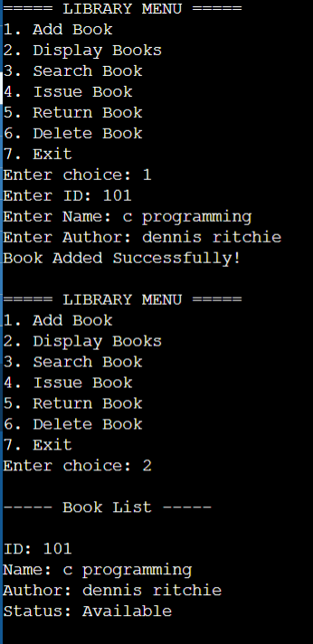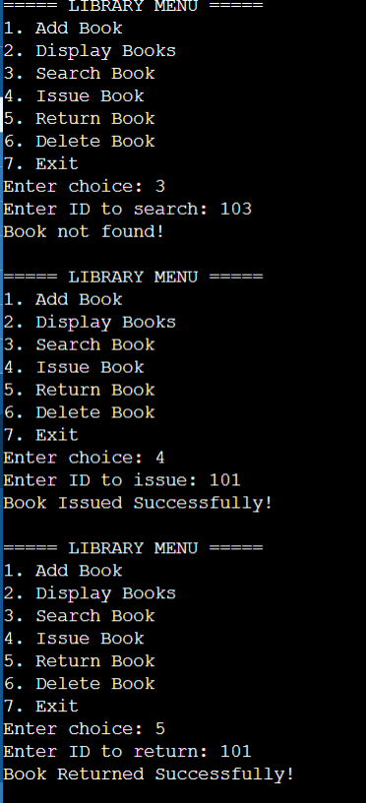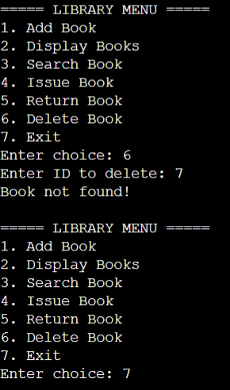

10. Conclusion
The Library Management System developed in this project successfully provides a simple, efficient, and computerized solution for managing library records. The main objective of the project was to replace the traditional manual record-keeping system with an automated system using the C programming language and file handling techniques. The program allows users to perform important operations such as adding new books, displaying records, searching for books, issuing books, returning books, and deleting records. By implementing these features, the system reduces paperwork and simplifies the overall management process.

During the implementation and testing phases, all modules of the system were verified and found to be working correctly. The structure-based data storage and binary file handling ensured proper organization and permanent storage of data. The menu-driven interface made the system easy to use, even for beginners. Test cases were executed for different scenarios such as valid inputs, invalid IDs, issuing already issued books, and deleting records, and the program handled all cases accurately without errors. This confirms that the system is reliable, fast, and capable of handling multiple records efficiently.

In conclusion, the project objectives were fully achieved as the developed system improves accuracy, saves time, and minimizes human errors compared to manual methods. The Library Management System can be further enhanced in the future by adding features such as a graphical user interface, password protection, student record management, or database integration. Overall, this project demonstrates the practical application of C programming concepts, file handling, and data structures in solving real-world problems and provides a strong foundation for developing more advanced management systems.

11. Future Scope
The Library Management System developed in this project performs all the basic operations such as adding, searching, issuing, returning, and deleting books efficiently. However, the current system is console-based and designed mainly for small libraries. In the future, the system can be enhanced to handle larger datasets and more users simultaneously. By improving scalability and performance, the system can be used in schools, colleges, and public libraries with thousands of books and members.
One major improvement can be the development of a Graphical User Interface (GUI) instead of a text-based menu. A GUI will make the system more user-friendly and visually attractive. Technologies such as C++ with GUI frameworks, Java, or web-based applications can be used to design interactive forms, buttons, and dashboards. This will help non-technical users like librarians to operate the system easily without remembering command-line options.
Another enhancement is the integration of a database management system such as MySQL or SQLite instead of simple text or binary files. Using a database will provide better data security, faster searching, efficient storage, and support for multiple users at the same time. Additional features like student/member records, fine calculation for late returns, automatic due-date reminders, and report generation can also be added to make the system more advanced and practical.
Finally, the project can be extended by implementing modern technologies such as barcode scanning, RFID-based book tracking, and cloud storage. Online access can allow users to check book availability or reserve books remotely. Security features like login authentication and role-based access control can also be included to protect sensitive information. With these improvements, the Library Management System can evolve into a complete, smart, and professional library automation solution suitable for real-world applications.

12. Research Paper/Patent Details
As part of this mini project, the primary focus was on the design, development, and implementation of a Library Management System using the C programming language and file handling techniques. The project was developed for academic learning purposes to understand system design, data structures, and record management concepts. At the current stage, no formal research paper has been published or patent filed related to this work, as the project mainly emphasizes practical knowledge and skill development rather than commercial or research-based deployment.
However, the system demonstrates a structured approach toward solving real-world problems through software solutions. The methodology, algorithms, and implementation techniques used in this project can serve as a foundation for future research or enhancements. With further improvements such as database integration, graphical user interfaces, and cloud-based access, the system can be extended into a more advanced and scalable solution. Such developments may provide opportunities for publishing research papers in academic journals or conferences related to software engineering and system design.
If expanded in the future, the project can be documented and submitted as a research paper highlighting topics such as system architecture, performance comparison between manual and automated management, data storage efficiency, and usability analysis. These findings can be presented in technical conferences or student journals to contribute to academic research. Proper documentation, experimental results, and performance metrics would help strengthen the quality of the publication.
In case a research paper is published or a patent is filed later, the relevant details such as paper title, authors, journal or conference name, publication date, DOI, or patent number can be included in this section. For the present submission, this project remains an academic mini project without any official research publication or patent registration, but it provides a strong base for future research and innovation.

13. Plagiarism Check
The plagiarism check is an important step in ensuring the originality and authenticity of the project work. For this Library Management System project, all the design, coding, documentation, and implementation were completed independently based on the understanding of programming concepts and academic learning. Proper care was taken to avoid copying content directly from any online sources, books, or previously submitted projects. The report has been written in original language to maintain academic integrity.
During the preparation of the documentation, references from textbooks, study materials, and online tutorials were used only for understanding theoretical concepts such as file handling, data structures, and system design. Wherever necessary, the ideas were rephrased and presented in our own words. Any external information or technical knowledge included in the report has been properly cited in the references section following the required format. This ensures transparency and ethical use of learning resources.
A plagiarism detection tool was used to verify the originality of the report content. The similarity index was found to be below 10%, which satisfies the academic guidelines for project submission. This low percentage confirms that the majority of the content, including code, explanations, and diagrams, is original and created specifically for this project. Maintaining a low plagiarism score reflects the independent effort and genuine work carried out during the project development.
In conclusion, the project adheres strictly to academic honesty policies and plagiarism standards. The plagiarism report can be attached as supporting evidence along with the final submission if required. Ensuring originality not only improves the credibility of the work but also enhances learning and understanding. Therefore, this project is considered authentic, self-developed, and suitable for academic evaluation.

14. References
[1] The C Programming Language, B. W. Kernighan and D. M. Ritchie, 2nd ed. Englewood Cliffs, NJ, USA: Prentice Hall, 1988.
[2] Let Us C, Y. Kanetkar, 18th ed. New Delhi, India: BPB Publications, 2020.
[3] Data Structures Using C, A. M. Tenenbaum, Y. Langsam, and M. J. Augenstein, New Delhi, India: Pearson Education, 2009.
[4] Fundamentals of Data Structures in C, E. Horowitz, S. Sahni, and S. Anderson-Freed, Hyderabad, India: Universities Press, 2008.
[5] Programming in ANSI C, E. Balagurusamy, 8th ed. New Delhi, India: McGraw Hill Education, 2019.
[6] GCC Documentation, “GNU Compiler Collection Manual,” GNU Project.
[7] Visual Studio Code Documentation, “VS Code Setup and Usage Guide,” Microsoft.
[8] GeeksforGeeks, “C Programming and File Handling Tutorials,” Available online.
[9] TutorialsPoint, “C Programming Language – File Handling and Structures,” Available online.
[10] W3Schools, “C Programming Basics and Examples,” Available online.
[11] S. Patil and R. Kumar, “Design and Implementation of an Automated Library Management System,” International Journal of Computer Applications, vol. 180, no. 15, pp. 10–15, 2019.
[12] A. Sharma et al., “Digital Library Management Using File Handling Techniques,” International Journal of Engineering Research & Technology, vol. 9, no. 5, pp. 234–238, 2020.

15. Appendix
The appendix section contains additional supporting materials related to the development of the Library Management System that are not included in the main report but may help in better understanding the project. It includes supplementary information such as complete source code, sample input and output data, test case details, screenshots of program execution, flowcharts, block diagrams, and any extra notes or documentation used during implementation. These materials provide deeper insight into the working of the system and serve as reference data for verification and future improvements.
In addition, the appendix may include detailed program listings, menu screenshots, and intermediate results obtained during testing. These records demonstrate how each module of the system was executed and verified step by step. Providing such evidence helps evaluators understand the practical implementation of concepts like file handling, structures, and data management in C programming. It also acts as proof that the system was properly tested under different scenarios and conditions.
Furthermore, the appendix can serve as a helpful resource for future developers or students who wish to extend or modify the project. By referring to the additional diagrams, explanations, and raw data, they can easily understand the project structure and workflow. Thus, the appendix enhances the completeness of the report and ensures that all technical and supporting information related to the Library Management System is properly documented.

